# PYTHON - BUILT IN DATA STRUCTURES

In Python, there are **four main built-in data structures**. These are like **containers** used to store, organize, and work with data efficiently.

## List

* A list is an **ordered** collection that can hold **any type of data**
* Uses **square brackets** []
* It is **mutable**- Its items can be changed (add, remove, change, sort etc.)
* List are similar to tuples except that their elements are mutable (can be changed)

Example

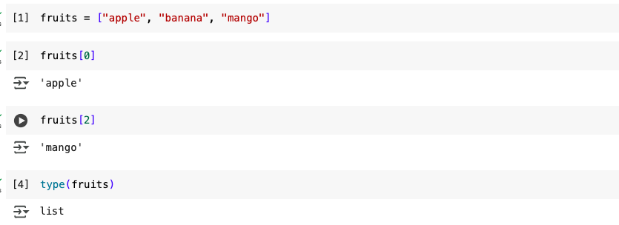

**Tuple**

* Tuples are a data type used to store a collection of immutable(unchangeable) data
* Uses **parentheses** ()
* It is similar to a list, but **immutable**- its items cannot be changed
* Examples of immutable items are gender (m/f), blood groups etc.
* Items are accessed using their position in the tuple
* It is ordered

Example

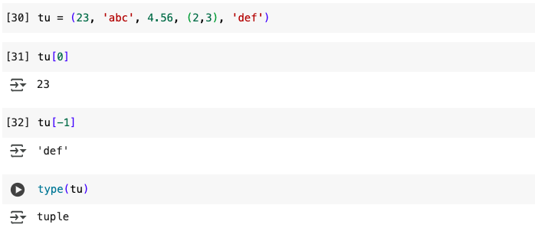

**Dictionary**

* Dictionaries are data structures which are used to store values which are accessed by their keys.
* Uses **curly braces** {}
* They are usually referred to as key value pairs. Each key, value pair is separated using a colon.
* Operations on a dictionary include: adding an item, deleting an item, accessing an item and looping through the items in the dictionary
* The following examples illustrate
* Stores data in key-value pairs
* Dictionaries store a mapping between a set of keys and a set of values
* A single dictionary can store values of different types
* You can defne, modify, view, lookup or delete the key-value pairs in the dictionary
* Python’s dictionaries are also known as hash

Example

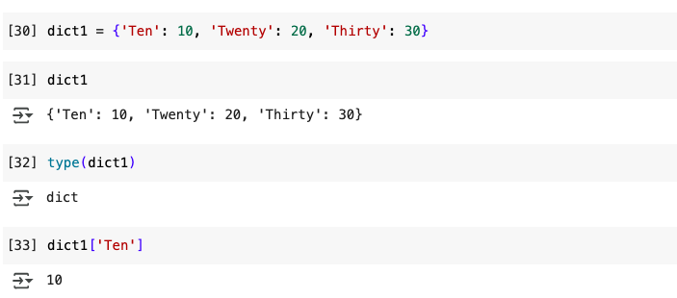

Modifying a dictionary

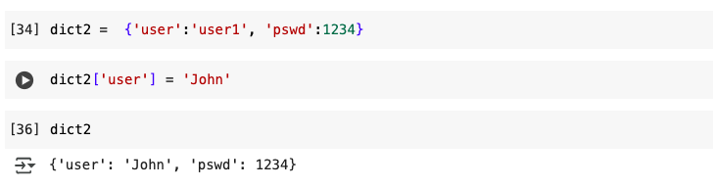

Adding and deleting an item from a dictionary

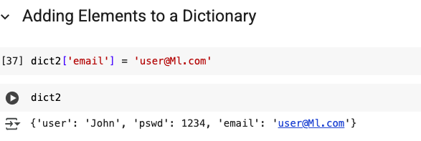

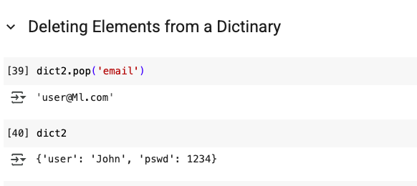

Dictionaries have several inbuilt functions

* dict.clear() - Removes all the elements from dictionary dict
* dict.copy() - Returns a copy of dictionary dict
* dict.items() - Returns a list containing a tuple for each key-value pair in dictionary dict
* dict.get(k) - Returns the value of the specified key k from dictionary dict
* dict.keys() - Returns a list containing all the keys of dictionary dict
* dic.pop(k) - Removes the element with the specified key k from dictionary dict
* dic.values() - Returns a list of all the values in dictionary dict

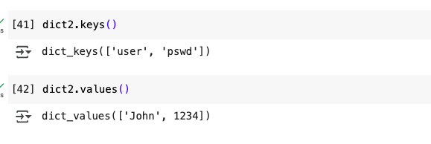

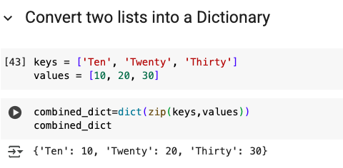

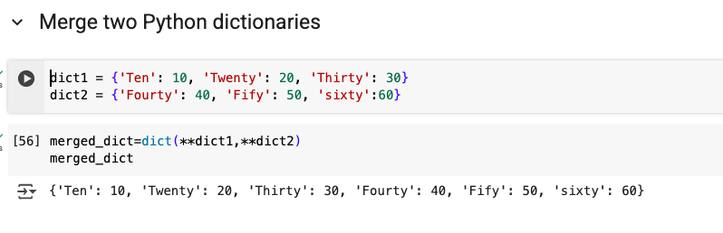

**Set**

* An **unordered** collection of **unique items**
* Removes duplicates automatically
* Uses **curly braces** {}, but different from dictionaries

Example

